Customer and Location Sales

Pharma Sales Dashboard

# Customer Sales by Product

Femara FCT | 53

# Location Sales by Location

Calabar | 14.6

Codiovan FCT | 243

Coartem Tab | 207

Tegretol Tab | 110

Aﬁnitor Tab | 111

Brinerdine SCT | 111

Lescol HGC | 123

Lagos | 260

Kano | 260

Ilorin | 90.72

Abeokuta | 124.34

Ibadan | 146.92

Port Harcourt | 150.64

Zaditen SRO FCT | 161

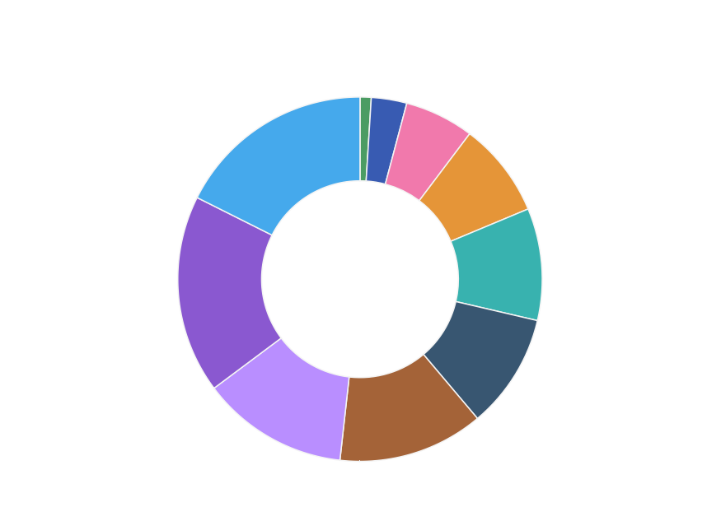

Ritalin Tab | 136

Galvusmet FCT | 126

Kaduna | 192.4

Warri | 190.66

Sales by Sales Representative and Received Inventory By Supplier

# Sales by Sales Representative Received Inventory by Supplier

700

|  |  |  |  |  |  |
| --- | --- | --- | --- | --- | --- |
|  |  |  |  |  |  |
|  |  |  |  |  |  |
|  |  |  |  |  |  |
|  |  |  |  |  |  |
|  |  |  |  |  |  |
|  |  |  |  |  |  |

600,000

650

500,000

600

400,000

550

300,000

500

200,000

450

100,000

400

0



Astra Zeneca

Novartis

Pﬁzer

Sanoﬁ

Inventory Stock by Warehouse Location and Sales Trend

# Inventory Stock by Warehouse Location

Target Actual

# Sales Trend

Kano | 73,080

Lagos | 60,424.17

Abeokuta | 48,560

Calabar | 4,080

Ilorin | 15,820

Abuja | 17,910

Warri | 41,890

Kaduna | 42,920

Ibadan | 44,340 Port Harcourt | 47,220

1,200

1,000



|  |  |  |  |  |  |  |  |  |  |  |  |  |
| --- | --- | --- | --- | --- | --- | --- | --- | --- | --- | --- | --- | --- |
|  |  |  |  |  |  |  |  |  |  |  |  |  |
|  |  |  |  |  |  |  |  |  |  |  |  |  |
|  |  |  |  |  |  |  |  |  |  |  |  |  |
|  |  |  |  |  |  |  |  |  |  |  |  |  |
|  |  |  |  |  |  |  |  |  |  |  |  |  |
|  |  |  |  |  |  |  |  |  |  |  |  |  |
|  |  |  |  |  |  |  |  |  |  |  |  |  |

800

Values

600

400

200

0

January

February

March

April

May

June

July

August

September

October

November

December



Monthly Sales and Actual /Received Inventory by Month

400

350

300

250

# Monthly Sales by Product

**Actual and Received Inventory by Month**

Actual Received Inventory 4,500

4,000

3,500

3,000

200

2,500

150

2,000

100

50

0

1,500

1,000

500

0

January

February

March

April

May

June

July

August

September

October

November

December

